NEWSPAPER

LIFE
WATER IS IMPORTANT
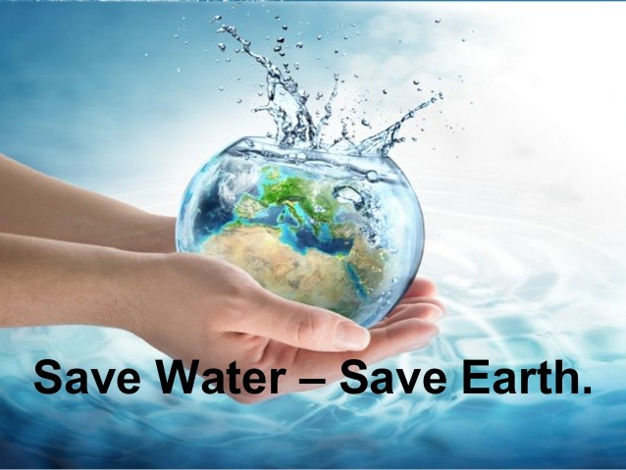  SAVE WATER-SAVE EARTH  WATER SURPRISE  Anita nabernik  To make one car we use an average of 380000 liters of water, 900 liters per kilogram of corn, 40 liters for one slice of bread, 3000 liters for 1 kilogram of sugar, we use 8000 liters of water for one pair of jeans, 2700 liters of water for one cotton shirt ,…  we are not aware of how much water we actually consuming. And I can tell you that we use absolutely too much water.  Water is priceless, and we have to start appreciate it.  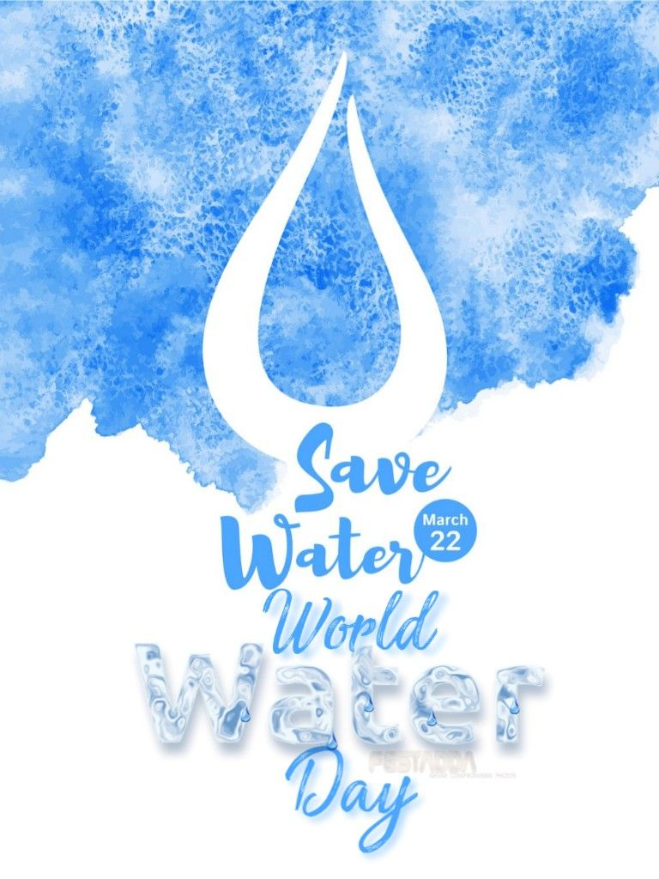  SAVE WATER  COMIX NAME: HOW MUCH WATER DO WE NEED? | 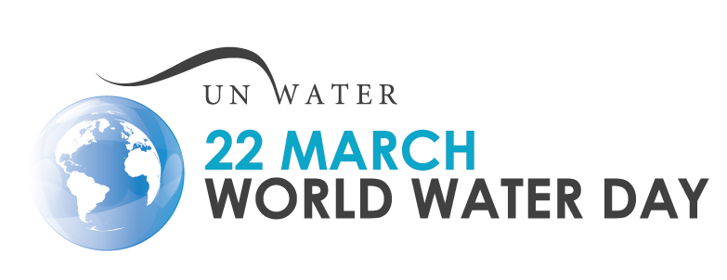  WORLD WATER DAY, 22.3  WORLD WATER DAY
 | aNITA NABERNIK  We commemorate World Water Day every year on March 22, since 1992, when it was selected at the United Nations Conference on Environment and Development in Rio de Janeiro, Brazil. Purpose is to raise awareness of the importance of drinking water and the sustainable use of aquifers.  This year's central theme: "Don't ignore anyone"  By definition, this means that we must not ignore anyone, leave us behind. | However, billions of people still live without safe drinking water today, fighting for the existence and development of their house, schools, jobs, farms, factories.  This year's World Water Day is designed to tackle the global water crisis by addressing the reasons why so many people are being ignored.
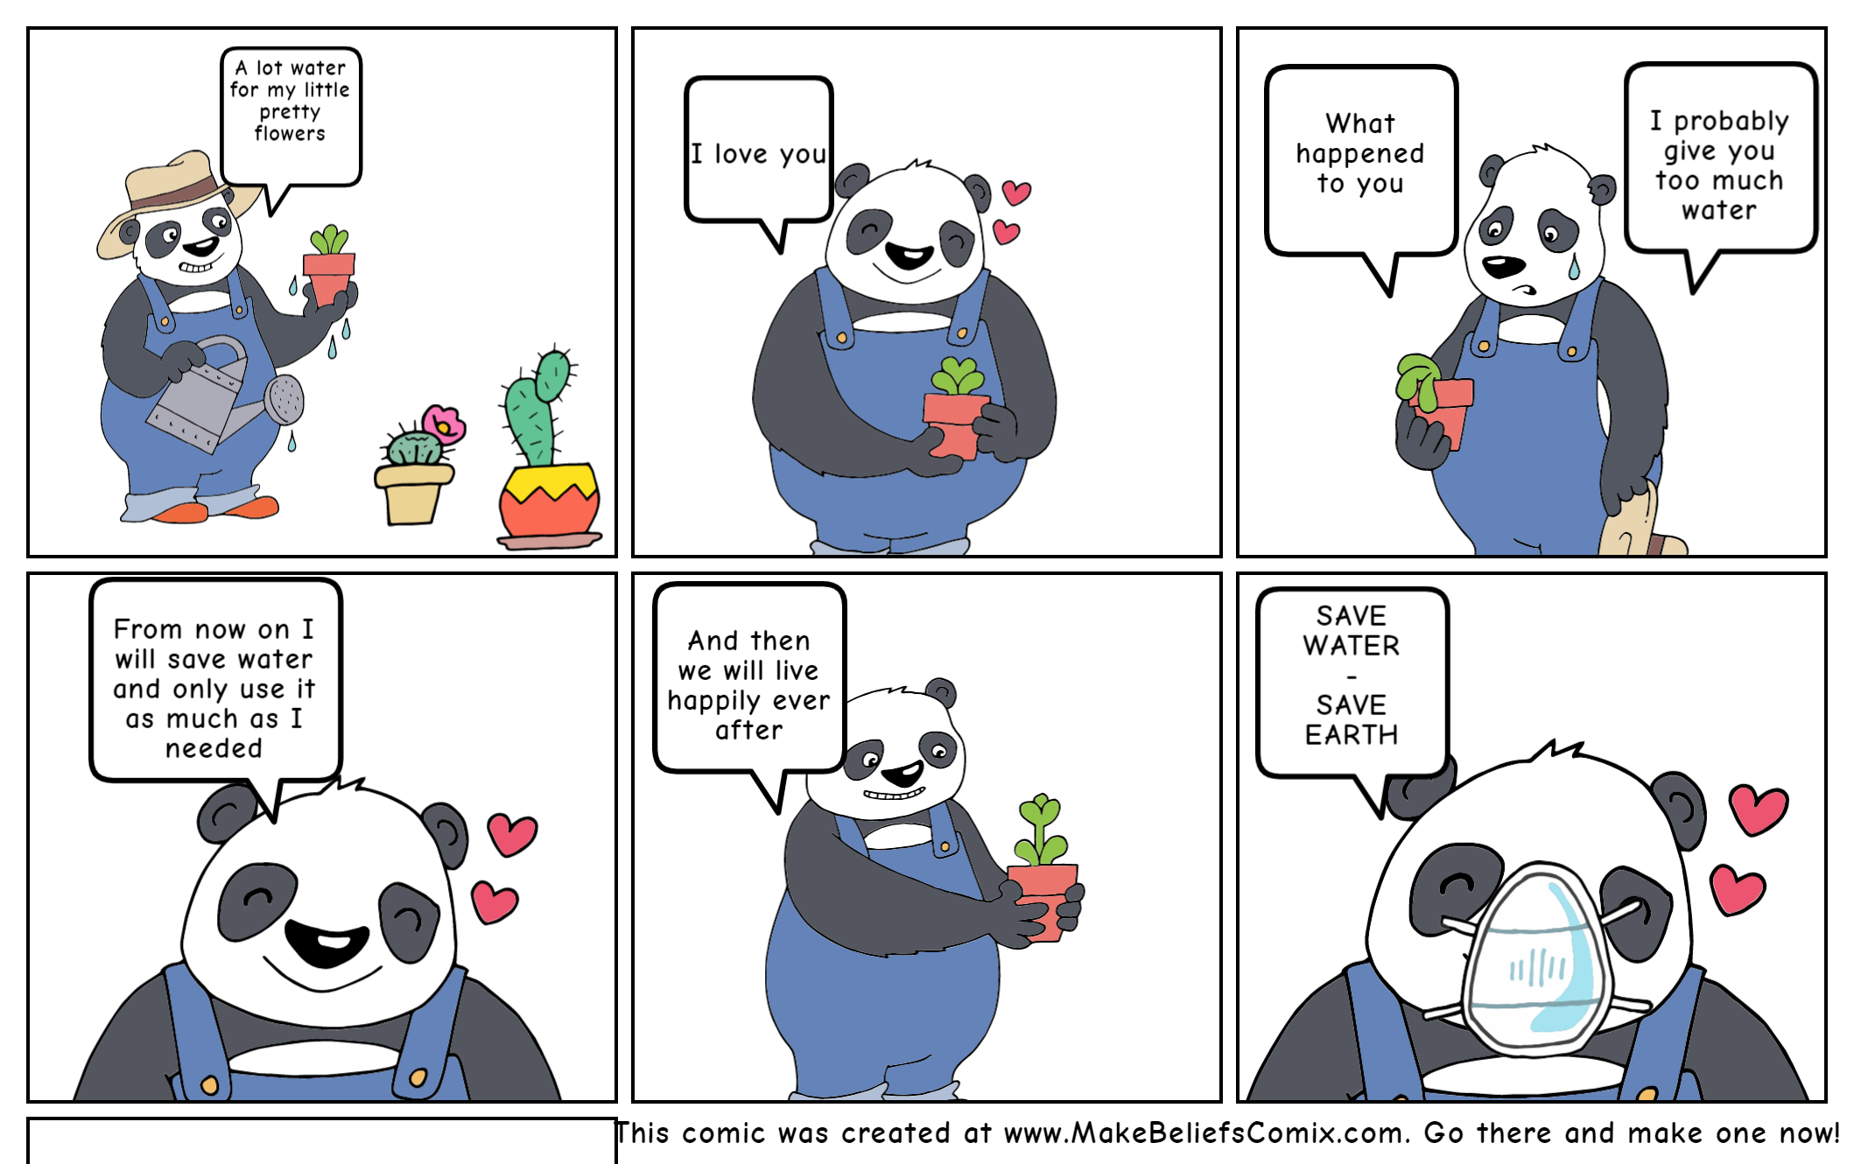
AUTHOR’S NAME: ANITA NABERNIK

